The Taroom Show went off with a blast in its 114th year with a record number of nominations as well as attendants who enjoyed the immaculate grounds of one of Queensland’s most popular regional agricultural shows.
Numbers in both the prime and stud cattle ring were at a surprising all time high considering we have recently endured our lowest summer in history. Stud cattle Chief Steward Ben Adams, Dangarfield, Taroom, said it was in fact the second largest showing in 13 years. This is believed to be down to the rich prize pool worth $18,000, which attracts a strong field of entries from locals as well as those further away including interstate. All cattle sponsors are responsible for contributing to such valuable prize money, for which the Taroom Show Society cannot thank these families and businesses enough.
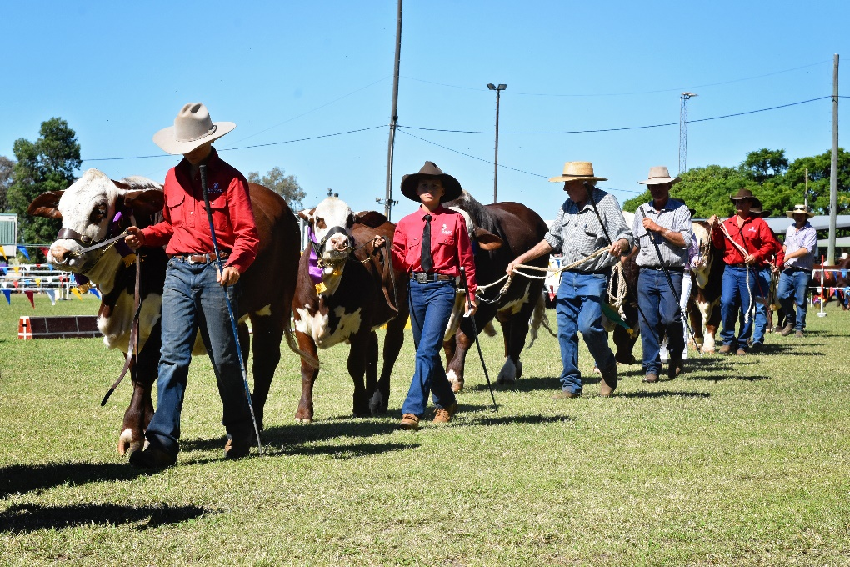
In the stud cattle section, the Braford Feature Show was a huge success with 43 nominations in total including 14 bulls. Little Valley Brafords took some notable prizes home to Casino including but not limited to the senior champion bull, calf champion female, junior champion bull and junior champion female. Judge Warren Wilson from Taroela Braford Stud and associate Airlie Treloar from Chessington Braford Stud, SA, awarded the grand champion female and reserve champion female to cattle of Robert and Lesette Hoffmann of Downfall Creek, Guluguba.
Daniel and Kasey Phillips, Wandoan, took home the interbreed champion female ribbon for 30-month-old Murgona Kleopatra with heifer calf Murgona Madonna at foot, after claiming the grand champion Bos Indicus female. Elite Nitrous, exhibited by Glen Waldron and Kim Groner, Elite Simmentals, Meandarra, won the interbreed champion bull. Elite Simmentals also won the champion interbreed breeders group.
Taking out the Super Bull Challenge was Acacia Eric N12 from Acacia Angus Stud, Killarney, while Glenlands D Amazon from Glenlands Droughtmaster was the junior bull challenge champion.
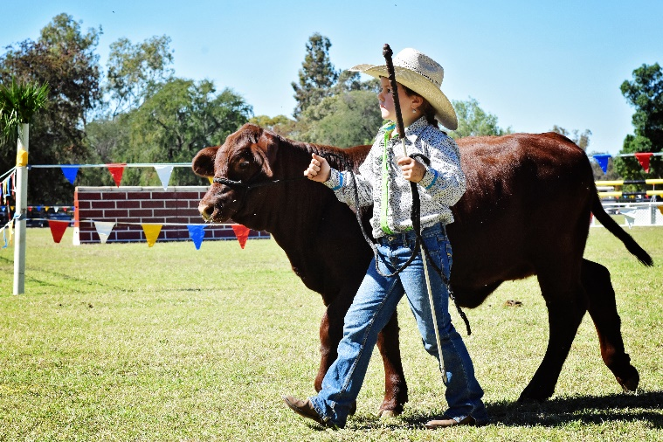
Also notable was the high number of youngsters taking part in the young judges and paraders’ competition. It is a delight to see the next generation showing such keen interest and keeping the show tradition strong. Thank you to St Brendan’s & St Ursula’s Schools, Yeppoon, for bringing their ag students down to take part.
For a run down on the prime cattle section – please see the following article.
Our volunteer stewards and judges were kept busy in the three rings with horse events over the entirety of the show. A large number of horses and riders kicked off participation on the Sunday. Gracie Bunker, fresh on the horse after recovering from a wrist injury, took some prizes home in the junior jumping competitions on her horse Wathonga Topez. Nicole Robertson also did significantly well on Helidon Park Eclipse. Kalli Nowell wooed the judges and the crowd, taking the title of “Smartest on parade.” Well done Kalli (and mum and co.) for showing them how it’s done! Kandi McLennan was another local who performed well on Sunday, continuing her success in the hack classes to take supreme rider of the show on Tuesday.
The four degrees celsius temperature did not deter the horse enthusiasts on Monday morning with Carlyn Brennan winning the best presented handler and later the supreme hack of the show. Melinda Cann won the led Australian Stockhorse (female) and Jack McGugan, the champion and reserve champion Quarter Horse (male and female). In the show jumping ring, Mitchell Everyingham took the Wright Family Open (1.20m), Ron Easey the MI Helicopters Open (1.35m), Clem Smith the Roberstons Transport Open (1.20m – 1.25m) and Clay Simmons the Black Truck Sales Open Grand Prix (1.35m+).
In the childrens’ ring, Ben and Mitch Williams did their parents proud in their age groups, as did Ayla and Ella Phillips, Katie and Gracie Bunker, Ruby Hooper, Riley Cann and Skye Lethbridge. Chloe Bruggermann riding Kennallywood Over The Rainbow won this year's prestigious Grant Bell Memorial Champion Local Rider under 17. As usual, the little ones were a sight to see in the fancy dress competition with Kalli Nowell winning first in the under 7s and Ruby Hooper taking the blue ribbon in the 7-10 year old category.
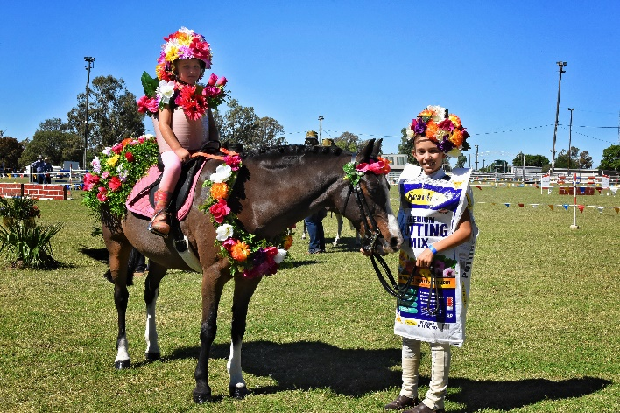
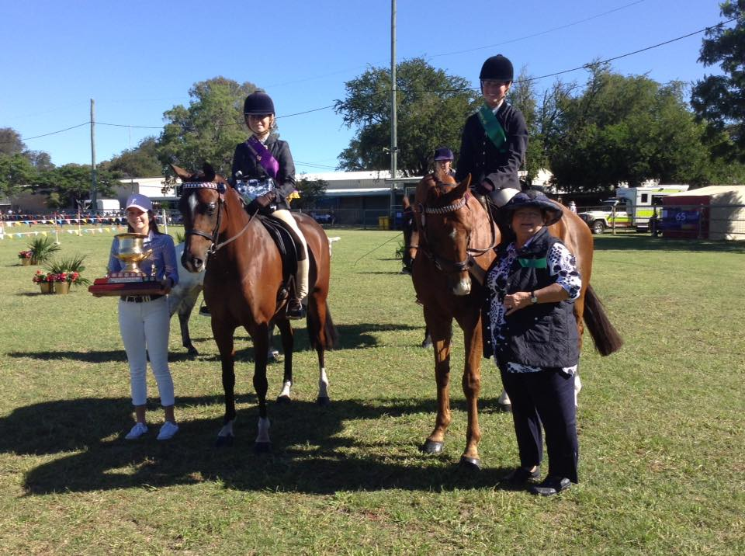

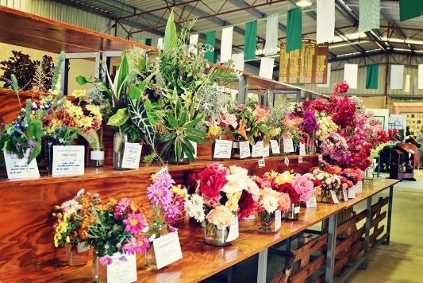
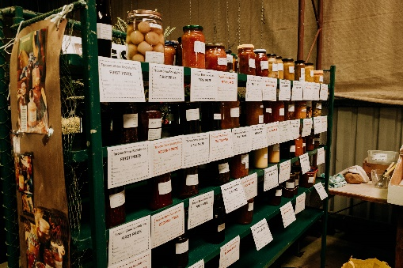
As for the Pavilion and Farm & Produce sections, there was an impressive array of exhibits on display. Terry Standing showed his hidden talent in winning the champion exhibit of the pavilion with a masterpiece saddle. Again, Deidre Jounquay proved hard to beat taking the well-deserved president's and patron's trophies for the most points gained across all sections of the show with her entries in the pavilion and farm & produce classes. The reputation of our show must be spreading wider, with exhibitor Jenny Fitzgerald from Dingo taking many prizes in the preserves. Val Neilson’s garden is obviously in full bloom after her gorgeous display of flowers won many first prizes in the horticulture section. The rustic garden art section also demonstrated a lot of skill and talent amongst our locals with Tania Baker’s barbed wire exhibit winning first. Marley Ellis showed she has been carefully watching her parents hard at work in the Adcakes van, taking the title of most points gained in the junior cookery section.
The popularity of the photography section is growing each year, with 43 entries in the children study class. A new display will be needed next year with this continuing growth! Sue Adcock, Benita Hay, Tania Baker and Tracee Hay were all successful competitors in this section, as were Tyler and Ella Bruggerman in the junior competition. The Taroom State School children also put in an impressive display of art & craft work and handwriting. In spite of the dry season, veggie patches appear to still be producing well, with prizes being awarded throughout the district in the farm & produce sections.
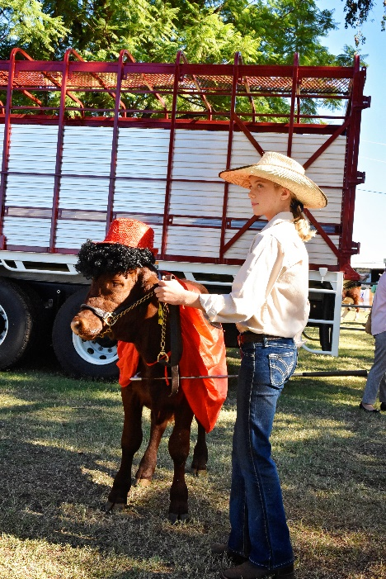
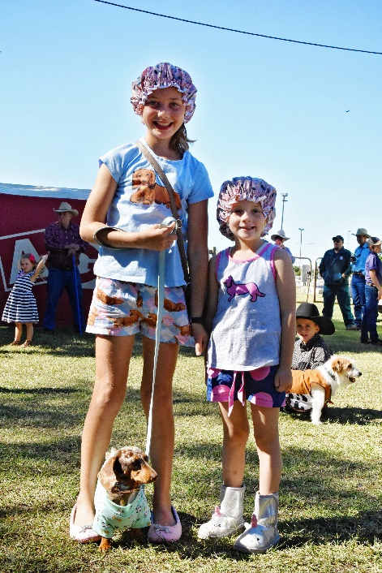
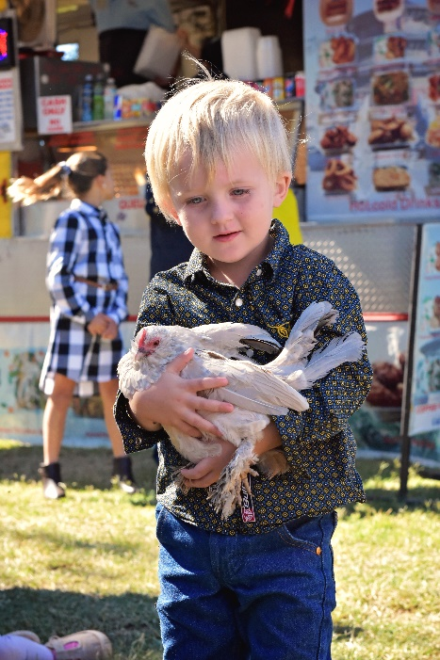
The happy and jovial crowd were spoilt for choice with the number of trade sites, shopping, displays and entertainment on offer. The Lego tent sponsored by Bendigo Bank was as usual a hit with the kids, along with Professor Wallace's puppets and Side Show Alley. The Taroom Vets Pet Parade was also a hub of activity with dogs of all shapes and sizes, poddy calves and pigs being shown off by their proud young owners. Quality beef from some of Taroom’s top graziers were also on display in the Dodgy Poddy calf competition with Lilly Adams winning Dodgiest Heifer with a fine specimen from Dangarfield followed by Taylor & Brian Phillips in second place and Owen & Ifan Croft the Dodgiest Steer with Bridie Bruggermann’s “Qantas” winning Best Poddy.
The Show Committee followed through on their promise that this year’s entertainment was going to be big. The Crack-Up Sisters entertained old and young with their hilarious comedy shows and whip cracking workshops on both Monday and Tuesday. Be sure to check out the videos on our Facebook site for some of our locals performing with them! KC's Monster Truck and Roly Poly Comedy Cars were well worth the wait on Tuesday evening. The deafening roar and the kicking of dirt from "Outback Thunder" left the audience in awe of the lucky few who won a ride. As usual, the Show finished with a bang with the magnificent display of fireworks.
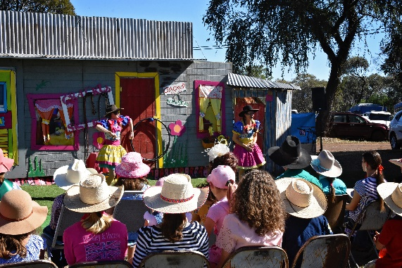
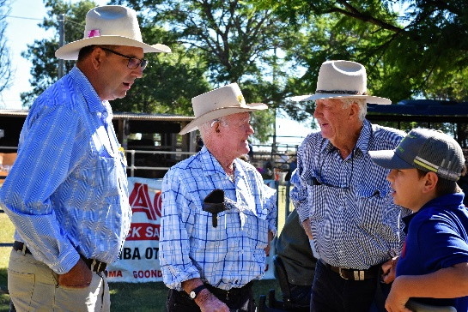
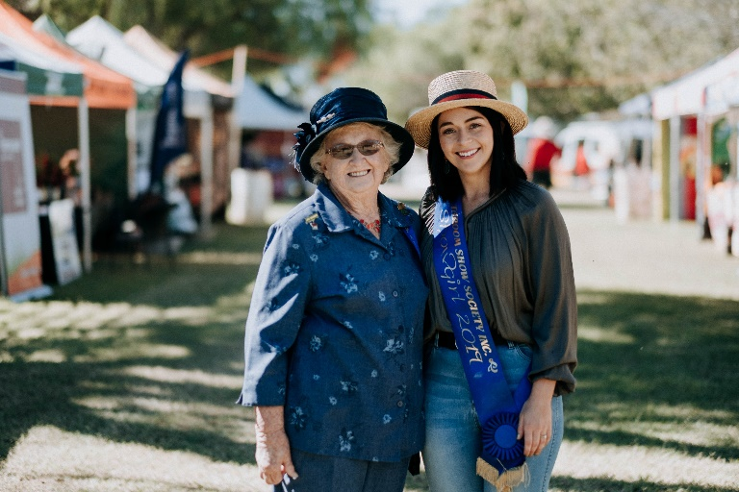
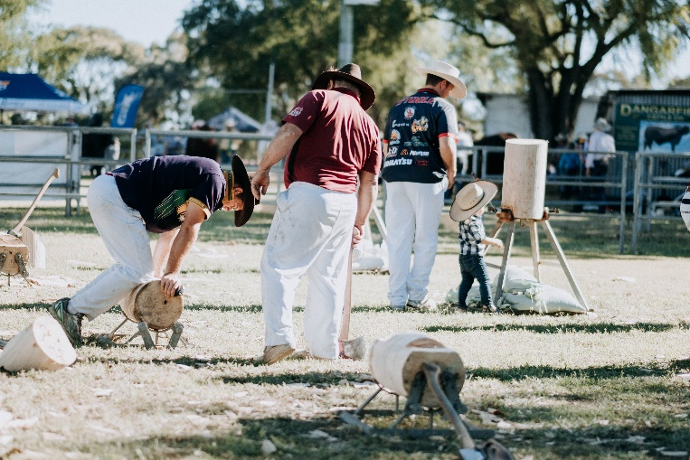
The Taroom Show Society would like to say a huge thankyou to the community for their support, to all sponsors and trophy donors of the Show, as well as all the members and volunteers who have dedicated endless hours in putting on and running a fantastic show. A special thank you also to the Taroom staff at Banana Shire Council and Snow Green who presented an immaculate field for the occasion. Without the help and assistance of you all, a show could not take place. We look forward to planning another blockbuster 2020 Taroom Show!
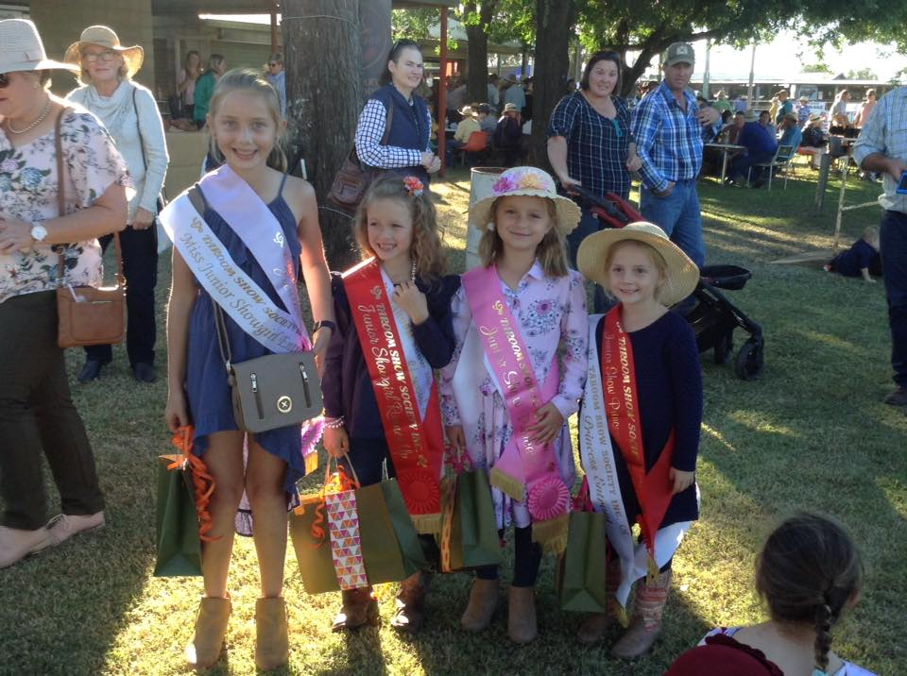
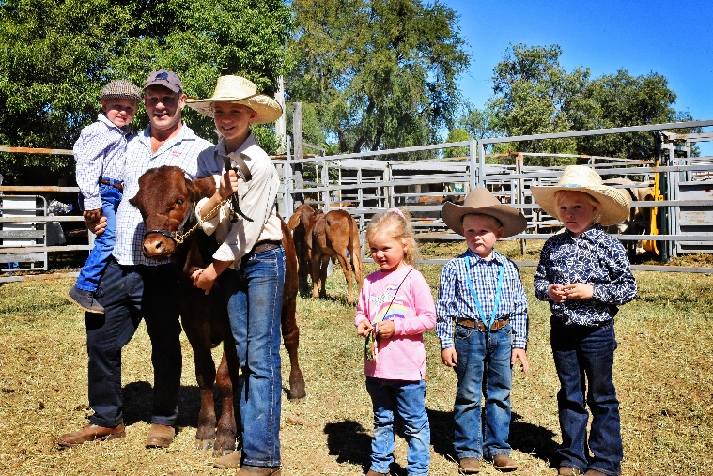

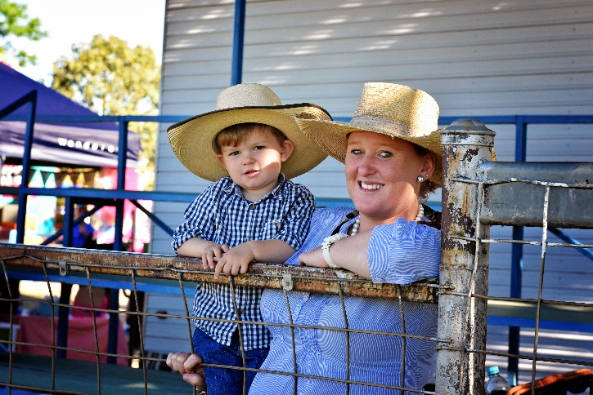
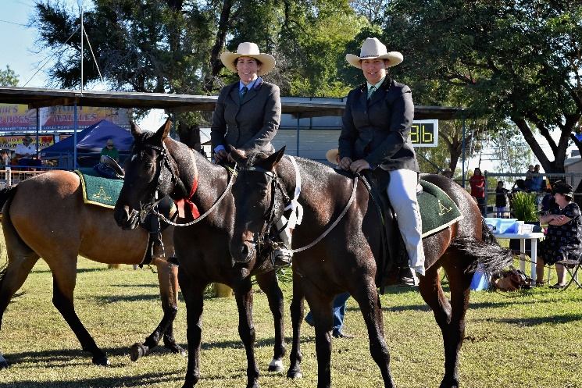
Check out our Facebook Show and Website (www.taroomshow.com.au) for full results and more photos.

